
AI-Based Personalized Learning Path Generator


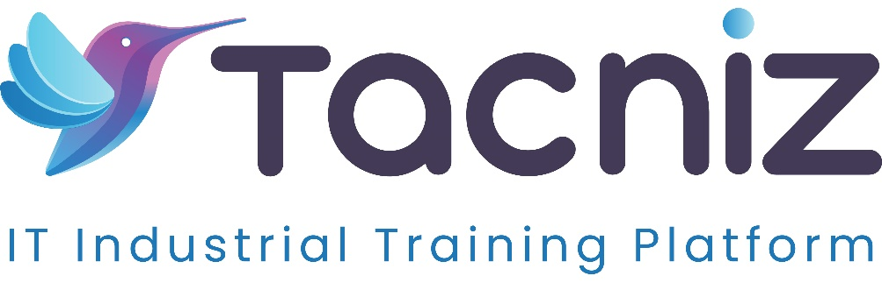

Problem Statement
Traditional education systems often struggle to meet the unique learning needs of each student, leading to a one-size-fits-all approach that may not maximize individual learning potential. Students have different learning styles, strengths, and paces of progress, which standard curricula cannot always accommodate. An AI-Based Personalized Learning Path Generator addresses this issue by analyzing each student’s learning style, progress, and strengths to create a customized curriculum. This platform adjusts lessons in real-time based on performance, optimizing learning efficiency and helping students achieve their full potential.

Project Type
- Type: Web and Mobile Application.
Category: Personalized Education, AI-Driven Learning, EdTech

Industry Area
- Industry: Education, Artificial Intelligence, Educational Technology (EdTech)
Relevant Sectors: Personalized Learning, K-12 Education, Higher Education, Corporate Training

Software Expertise Required
To develop an effective AI-based personalized learning platform, the following technical skills and tools are required:
- Machine Learning and Data Analytics: Proficiency in machine learning algorithms (such as decision trees, clustering, and reinforcement learning) to analyze student data and adapt the curriculum based on progress and performance.
- Natural Language Processing (NLP): Expertise in NLP tools (e.g., spaCy, GPT) for understanding and generating content that matches each student’s proficiency level and learning style.
- Data Visualization: Skills in data visualization libraries like Matplotlib, Seaborn, or D3.js to provide insights into student progress and performance.
- Frontend Development: Experience with React, Angular, or Vue for web applications, and React Native or Flutter for mobile applications, creating an intuitive user interface that is engaging and user-friendly for students and educators.
- Backend Development and Database Management: Proficiency in backend frameworks like Django, Flask, or Node.js, and database systems like MySQL or MongoDB to store student data, learning paths, and curriculum materials securely.
- Real-Time Data Processing: Knowledge of real-time data processing techniques to adjust lesson difficulty and content immediately based on student performance.
- AI-Based Recommendation Engine: Experience with recommendation algorithms that provide personalized lesson suggestions, helping students follow a curriculum that best matches their skills and needs.

Key Features
- Learning Style Analysis: The platform evaluates each student’s preferred learning style (e.g., visual, auditory, or kinesthetic) and tailors content to suit their preferences.
- Real-Time Curriculum Adjustment: Based on performance in each lesson, the system adjusts the difficulty level and content focus, ensuring continuous improvement and optimal challenge levels.
- Progress Tracking and Analytics: Students and educators can view detailed analytics on progress, highlighting strengths and areas needing improvement.
- Personalized Lesson Suggestions: The platform recommends specific lessons, topics, or exercises based on each student’s unique learning needs and recent performance.
- Feedback and Assessments: The platform provides assessments to gauge comprehension and offers immediate feedback, allowing students to correct misunderstandings and reinforce learning.
- Gamified Learning Elements: To enhance engagement, the platform can include gamification elements, such as achievement badges, progress rewards, and personalized goals.

Use Cases
- For K-12 Students: The platform creates tailored learning paths for students based on their grade level, strengths, and areas for improvement, helping them succeed in subjects where they need additional support.
- For Higher Education Students: College and university students can receive customized learning paths for complex subjects, optimizing their study routines and improving retention.
- For Teachers and Educators: Educators can track student progress, monitor learning patterns, and adjust teaching methods accordingly to better support each student.
- For Corporate Training Programs: Companies can use the platform to personalize training programs for employees, ensuring that each individual receives relevant content based on skill gaps and career goals.

Expected Outcomes
The AI-based personalized learning path generator will enhance student engagement, increase learning efficiency, and improve overall academic performance by tailoring lessons to individual needs. With real-time adjustments to the curriculum, students can progress at their own pace, reducing frustration and building confidence in their abilities. Educators benefit from data-driven insights that allow them to provide targeted support, while students experience a more satisfying, productive learning journey.

Benefits
- Enhanced Learning Efficiency: Real-time adjustments to lessons ensure that students spend time on topics they need most, optimizing study time and improving retention.
- Increased Student Engagement: By aligning content with each student’s preferences and strengths, the platform makes learning more enjoyable, increasing motivation and participation.
- Targeted Skill Development: Students receive personalized support on weaker subjects while progressing faster through content they have mastered, resulting in balanced skill development.
- Data-Driven Support for Educators: Educators gain insights into student performance, enabling them to offer tailored support and monitor learning trends.
- Self-Paced Learning: Students can progress at a pace that suits their unique needs, reducing stress and creating a positive learning environment.
- Scalable Solution for Diverse Learning Needs: The platform can serve students of various ages, subjects, and skill levels, making it a versatile tool for diverse educational settings.

Project Duration
- Estimated Duration: 5-6 months for development, testing, and deployment, with additional time allocated for refining the AI models, integrating real-time feedback, and optimizing the user interface for students and educators.

